DATA CLEANSING

Data cleansing activities are first of all we check whether there are null value in the data set we load, most of the csv we get is clean from null value but this step is mandatory.

Then we drop the first row, for the convenience way in dividing the test 20% and train 80 %

then I drop of the date feature, we don’t need that feature

I scale min max using scikit range 0-1

I load the train and te

I transform the dataset to be 3 dimensional array, it consist row,

FEATURE ENGINEERING

I don’t do the normalization in the model

I do the transformation to range 0-1

Then we drop the first row, for the convenience way in dividing the test 20% and train 80 %

then I drop of the date feature, we don’t need that feature

I scale min max using scikit range 0-1

I load the train and te

I transform the dataset to be 3 dimensional array, it consist row.

MODEL DEFINITION

I used LSTM model or Long Short Term Memory. It gives you the supervised learning data from the past that crucial in training the data that sensitive to time. LSTM is commonly used in stock market machine learning for prediction because it most suitable way to do the prediction of sequence and by time to time data.

MODEL TRAINING

I train the model in keras using epoch 1000 with 10 batch size. It is huge actually, but i think it is necessary to model to get better

I use LSTM keras library to train, with 125 input size, and 1,5 input shape

Then pass it to last layer/close layer or output layer, output layer is 1

I use adam optimizer

With 1000 epoch and 10 batch size.

I got between 4-6 RMSE layer but with great variation

Model Evaluation

From the current configuration i got 4-6 RMSE score (great variation). It quite impressive i thing and the graph is like this

In each epoch i got >10 loss but <15 error

After I do the change in epoch = 2000 and batch size 50, i got less than 7 loss in each epoch cycle. RMSE count score is 4.02 with low variation.

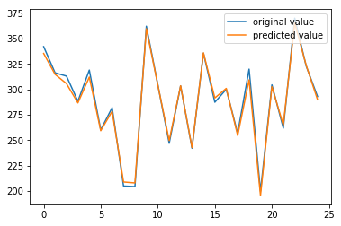

Model Deployed

The model Deployed by plotted by matplotlib and export it to pdf. The model it saved in h5 file for future need. The jupyter notebook saved.

